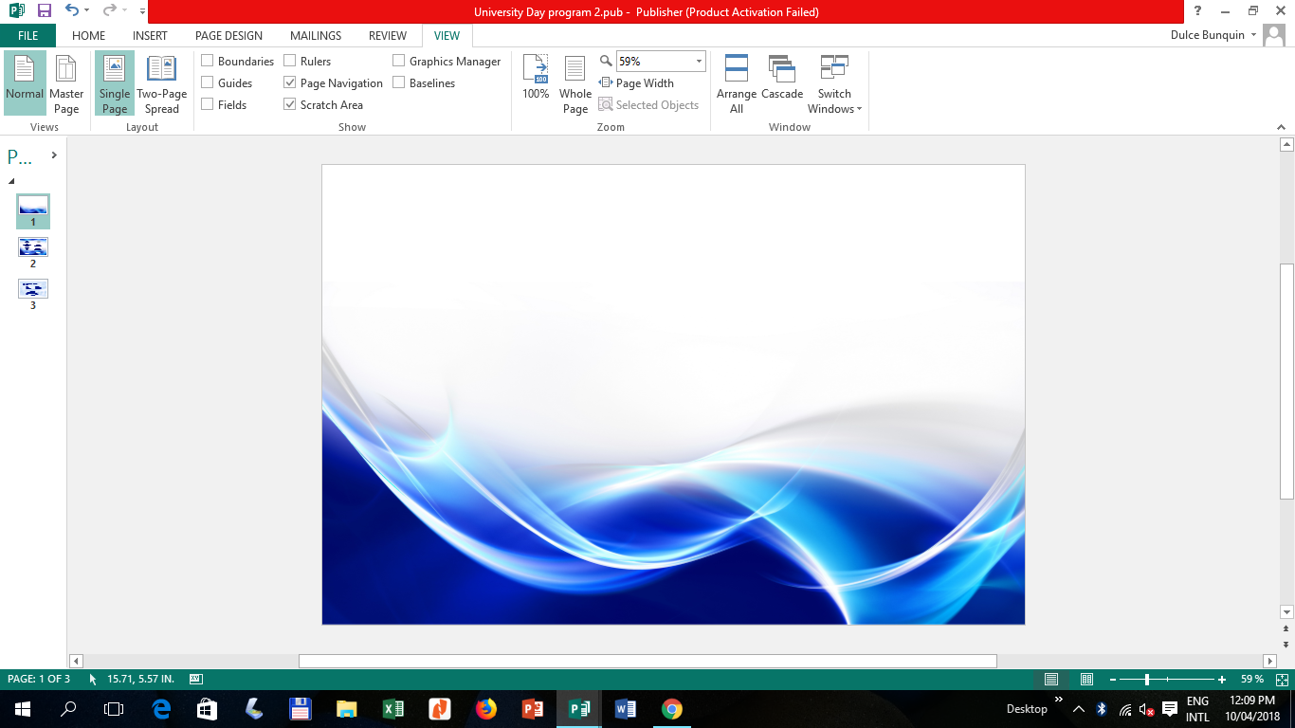



*A Strong Partner for Sustainable Development*

**Module**

**in**

**CHEM108**

**CHEMISTRY FOR ENGINEERS**

**COLLEGE OF ARTS AND SCIENCES**

Bachelor of Science in Electrical Engineering

Module No. **1**

**Introduction to Chemistry:**

**Matter and Measurement**

1st Semester 2020-2021

**NIESCEE EISCENE C. TALAMAN, RCh**

INSTRUCTOR

TABLE OF CONTENTS

|  |  |
| --- | --- |
| Title Page | 1 |
| Table of Contents | 3 |
| Instruction to the User | 4 |
| Introduction | 4 |
| Chapter 1. Title | 5 |
| Overview | 5 |
| Learning Outcomes | 5 |
| Pre-Test | 5 |
| Lesson 1 | 6 |
| Lesson 2 | 11 |
| Lesson 3 | 14 |
| Lesson 4 | 19 |
| Lesson 5 | 23 |
| References | 25 |
| Student Information | 26 |
| Vision, Mission and Core Values | 27 |

**Instruction to the User**

This module will provide you with an educational experience while independently accomplishing the task at your own time and pace. It also aims to ensure that learning is unhampered by health and other challenges. It covers the topic about the Introduction to Chemistry: Matter and Measurement.

Reminders in using this module.

1. Keep this material neat and intact.
2. Answer the pretest first to measure what you know and what to be learned about the topic discussed in this module.
3. Accomplish the activities and exercises as aids and reinforcement for better understanding of the lessons.
4. Answer the posttest to evaluate your learning.
5. Do not take pictures in any parts of this module nor post it to social media platforms.

Value this module for your own learning by heartily and honestly answering and doing the exercises and activities. Time and effort were spent in the preparation of this module so that your learning may continue amidst this Covid-19 pandemic.

**Introduction**

This module will serve as an alternative learning material to that of regular classroom teaching and learning delivery. The instructor will facilitate and explain the module to the students to achieve its expected learning outcomes, activities and to ensure that they will learn amidst of pandemic.

This material discusses the introduction to Chemistry for Engineers. It aims to teach you about Introduction to Chemistry: Matter and Measurement. It is very important that you cooperate by using this module page by page and completing all the given activities. At the end of the module, the learning outcome is evaluated based on the different tasks given to you.

Through your cooperation in this kind of flexible learning delivery, understanding chemistry in the study of matter, the changes it undergoes and the measurements used in chemistry is possible. It is expected that after using this module you will become well-oriented on the basics of chemistry and be aware that chemical principles operate in all aspects of our lives and everyday activities.

**Chapter 1**

**Title: Introduction to Chemistry: Matter and Measurement**

**Overview**

Chemistry is the heart of many changes we see in the world around us, and it accounts for the different properties we see in matter. As you progress in this study, you will come to see how chemical principles operate in all aspects of our lives, from everyday activities like food preparation to more complex processes such as those that operate in the environment.

**Learning Outcomes**

At the end of the chapter, you will be able to:

1. Distinguish among elements, compounds and mixtures
2. Identify symbols of common elements
3. Identify common metric prefixes
4. Demonstrate the use of significant figures, scientific notation and SI units in calculations
5. Employ dimensional analysis in calculations

**Pre-test**

**Instructions**: To test your prior knowledge, please answer the pre-test.

1. Define the 3 states of matter.
2. These substances cannot be decomposed into simpler substances.
3. What elements can exist naturally as diatomic?
4. Mixtures that are uniform throughout are called ____.
5. Provide the chemical symbol of the following:
6. Carbon
7. Magnesium
8. Copper
9. Silver

6. ____ properties do not depend on the amount of sample being examined.

7. ____ properties depend on the amount of sample, with two examples being mass and volume.

8. ____ is defined as the amount of mass in a unit volume of a substance.

9. _____ is a measure of the hotness or coldness of an object.

10. What is the SI base unit of length?

11. These mixtures do not have the same composition, properties, and appearance throughout.

12. Homogeneous mixtures are also called ________?

13. What kind of change happens when a substance changes its physical appearance but not its chemical composition?

14. What kind of change happens when a substance is transformed into a chemically different substance?

15. We can separate a mixture into its components by taking advantage of differences in their ____?

**LESSON 1. CLASSIFICATIONS OF MATTER**

1. Learning Outcomes

At the end of the lesson, you can

* 1. Distinguish elements, compounds and mixtures
  2. Identify Symbols of common elements
  3. Discuss the overview of the classification of matter

1. Time Allotment

1 session (1.5 hours)

1. Discussion

Chemistry is the study of matter and the changes that matter undergoes. We observe tremendous variety of matters in our world and one of our goals will be to relate the properties of matter to its composition and the particular elements it contains.

**FUNDAMENTAL CLASSIFICATION OF MATTER**

* Physical state (solid, liquid and gas)
* Composition (whether it is an element, compound, or a mixture)

**PHYSICAL STATES OF MATTER**

A **solid** has both definite shape and a definite volume. Neither liquids nor solids can be compressed to any appreciable extent.

A **liquid** has a distinct volume independent of its container, and assumes the shape of the portion of the container it occupies.

A **gas** (also known as vapour) has no fixed volume or shape; rather, it uniformly fills its container. A gas can be compressed to occupy a smaller volume or it can expand to occupy a larger one.

*Note: The physical state of the substance changes with the change in temperature.*

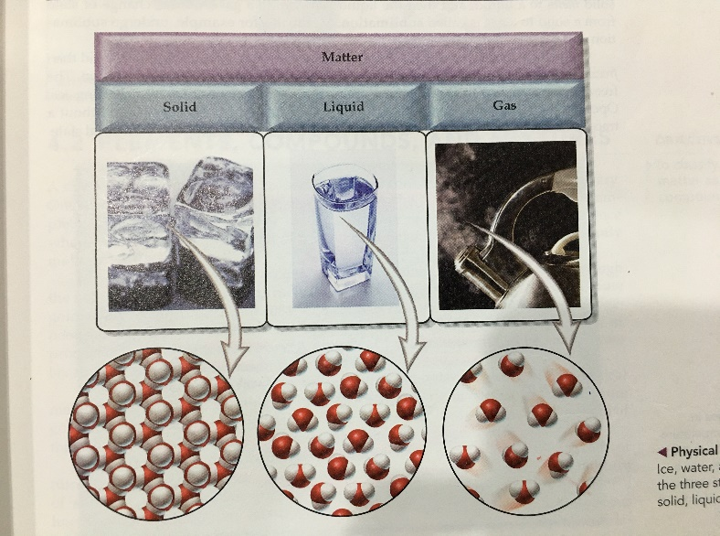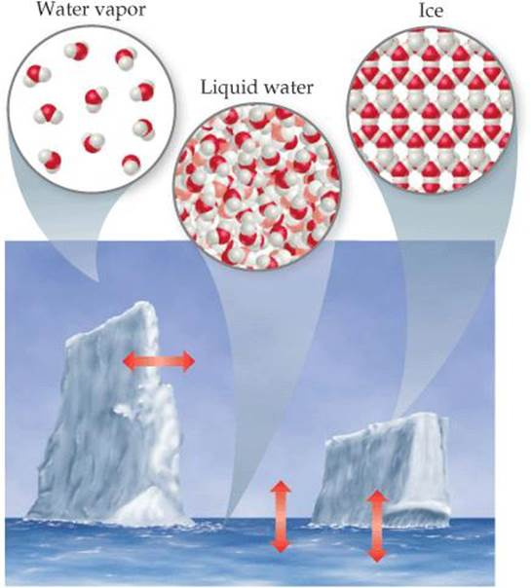

*Figure 1.1 Physical States of Matter*

|  |  |  |  |
| --- | --- | --- | --- |
| **PROPERTY** | **SHAPE** | **VOLUME** | **COMPRESSIBILITY** |
| **SOLID** | Fixed | Variable | Variable |
| **LIQUID** | Fixed | Fixed | Variable |
| **GAS** | Negligible | Negligible | Significant |

**CLASSIFICATION OF MATTER BY COMPOSITION**

**PURE SUBSTANCES**

Matter that has distinct properties and a composition that does not vary from sample to sample. Examples are water (a compound) and gold (an element).

* **Elements** are substances that cannot be decomposed into simpler substances.
* **Compounds** are substances composed of two or more elements; they contain two or more kinds of atoms.

**MIXTURES** are combinations of two or more substances in which each substance retains its chemical identity.

* **Homogeneous mixture** – properties and proportions are constant throughout the mixture. An example is salt solution.
* **Heterogeneous mixture** – properties and proportions vary throughout the mixture. An example is oil and water mixture.

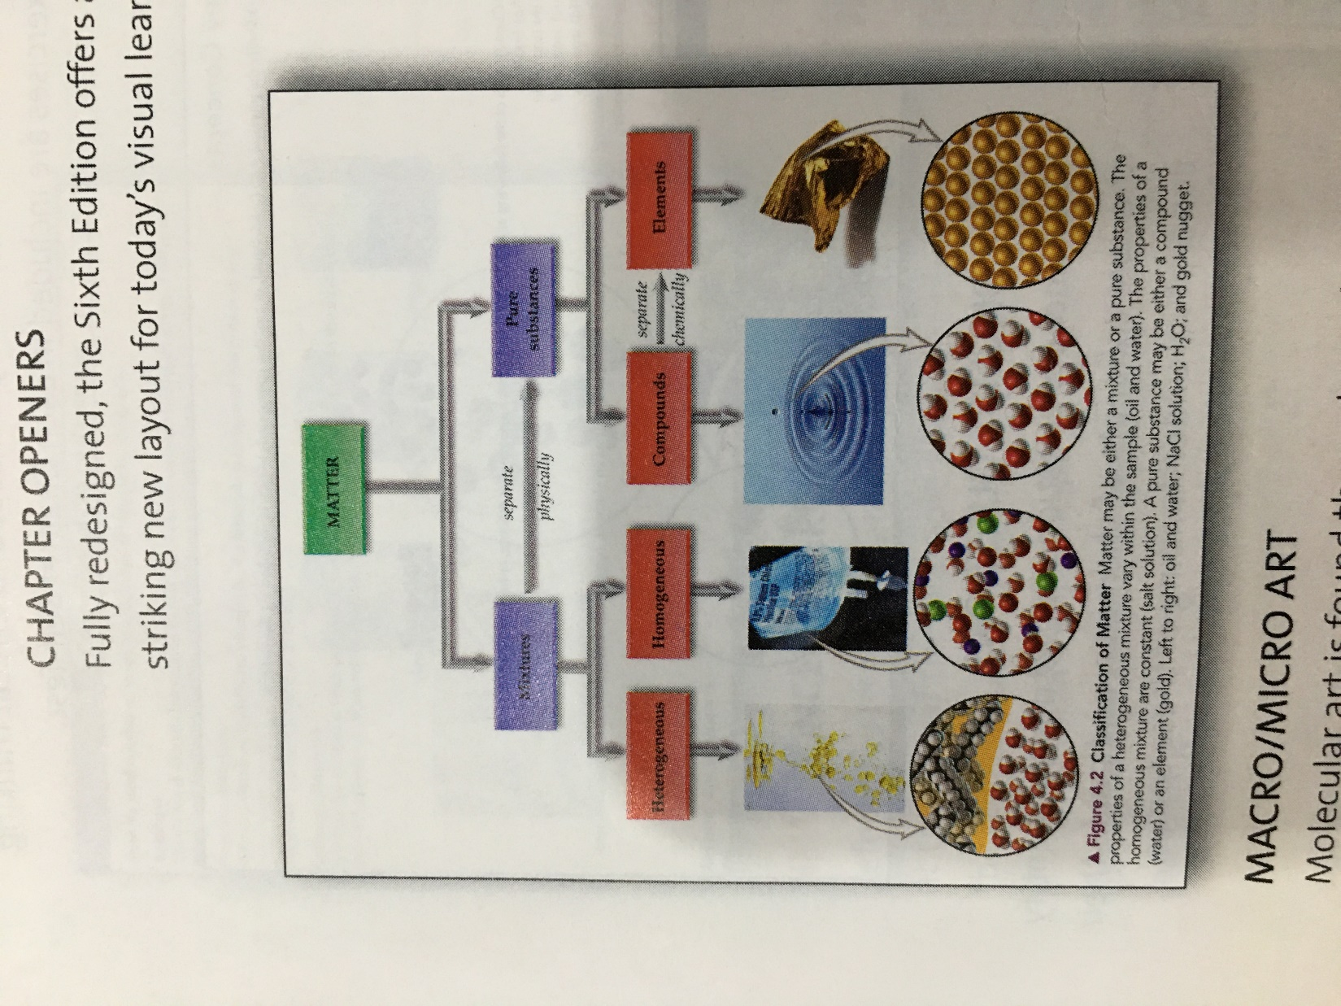

*Figure 1.2 Classification of matter by its composition*

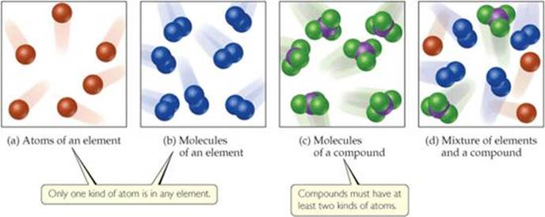

*Figure 1.3 Molecular comparison of elements, compounds, and mixtures.*

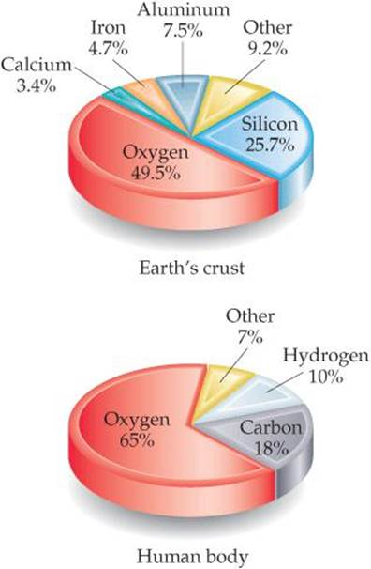**ELEMENTS**

There are only 118 elements known, varying in abundance. The Earth’s crust (including oceans and atmosphere) accounts for 90% of five (5) elements only, namely oxygen, silicon, aluminum, iron and calcium. The human body accounts for over 90% of three (3) elements only, namely oxygen, carbon and hydrogen.

Table 1.1 List of Common Elements and their Symbols

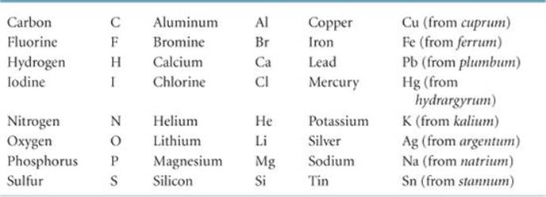

*Figure 1.4 Elements in in Earth's crust and the human body.*

***COMPOUNDS***

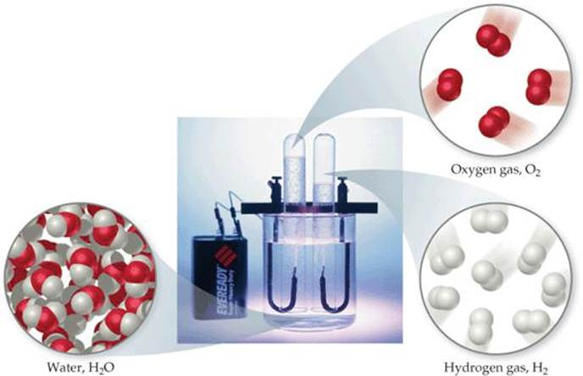Most elements can interact with other elements to form compounds. For example, when hydrogen gas burns in oxygen gas, the elements hydrogen and oxygen combine to form the compound water. Conversely, water can be decomposed into its elements by passing an electrical current through it.

In figure 1.5, water decomposes into its component elements, hydrogen and oxygen, when an electrical current is passed through it. The volume of hydrogen, collected in the right test tube, is twice the volume of oxygen.

*Figure 1.5 Electrolysis of water*

**Law of Definite Proportions**

It is the observation that the elemental composition of a compound is always the same. This is also known as the law of constant composition as stated by French chemist Joseph Louis Proust (1 754–1826).

Pure water, regardless of its source, consists of 11% hydrogen and 89% oxygen by mass. This macroscopic composition corresponds to the molecular composition, which consists of two hydrogen atoms combined with one oxygen atom:

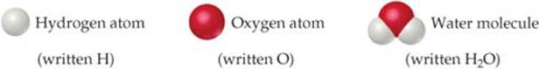

The elements hydrogen and oxygen themselves exist naturally as diatomic (two atom) molecules:

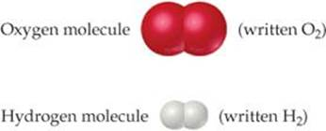

Hydrogen, oxygen, and water are each a unique substance, a consequence of the uniqueness of their respective molecules. The properties of water bear no resemblance to the properties of its component elements as seen in Table 1.2.

TABLE 1.2 Comparison of Water, Hydrogen, and Oxygen Properties

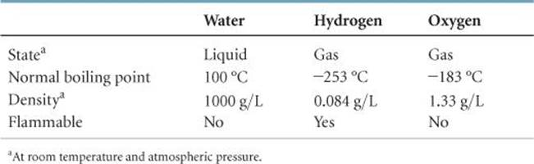

**MIXTURES**

In contrast to a pure substance, which by definition has a fixed composition, the composition of a mixture may vary. A cup of sweetened coffee, for example, can contain either a little sugar or a lot.

***Components*** of the mixture - the substances making up a mixture

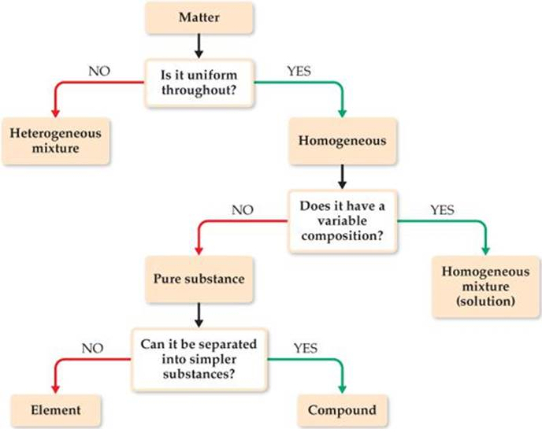

*Figure 1.6 Classification of Matter*

**Heterogeneous Mixtures**

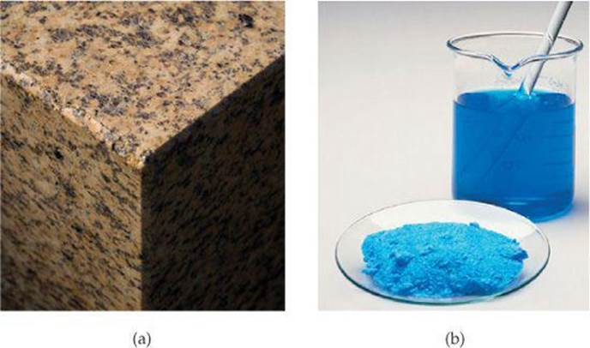These mixtures do not have the same composition, properties, and appearance throughout. Rocks and wood, for example, vary in texture and appearance in any typical sample.

**Homogeneous mixtures**

These mixtures are uniform throughout. Air is a homogeneous mixture of nitrogen, oxygen, and smaller amounts of other gases. The nitrogen in the air has all the properties of pure nitrogen because both the pure substance and the mixture contain the same nitrogen molecules. Salt, sugar, and many other substances dissolve in water to form homogeneous mixtures

*Figure 1.7 Mixtures. (a) heterogeneous mixture of granite and (b) homogeneous mixture of copper sulfate solution*

Homogeneous mixtures are also called ***solutions***. Although the term solution conjures an image of a liquid, solutions can be solids, liquids, or gases.

1. Activities/Exercises

1. Distinguishing among Elements, Compounds, and Mixtures.

“White gold” contains gold and a “white” metal, such as palladium. Two samples of white gold differ in the relative amounts of gold and palladium they contain. Both samples are uniform in composition throughout. Use Figure 1.6 to classify white gold.

1. Draw figures that represent the following:

2a. Pure element

2b. Pure compound

2c. Mixture of element and a compound

1. Provide the chemical symbol of the following elements:

3a. Mercury

3b. Iron

3c. Tin

3d. Lead

1. Evaluation/Post-test
2. What is a matter that has distinct properties?
3. These substances are composed of two or more elements; they contain two or more kinds of atoms.
4. Name the French chemist who introduced the law of constant composition or the law of definite proportions
5. What is the difference between homogeneous and heterogeneous mixtures? Give one example for each mixture.
6. Classify whether the following substances are pure substance or a mixture. If it is a mixture, indicate whether it is homogeneous or heterogeneous.

a. calcium

b. lake water

c. chocolate

**LESSON 2. PROPERTIES OF MATTER**

1. Learning Outcomes

At the end of the lesson, you can:

1. Identify different properties of matter;
2. Discuss different changes in matter; and
3. Understand and discuss different methods of separation of mixtures
4. Time Allotment

1 session (1.5 hours)

1. Discussion

**Categories of Properties of Matter**

Every substance has unique properties. One way to classify matter by properties is to use physical and chemical properties.

* **Physical properties**

These properties can be observed without changing the identity and composition of the substance. These properties include color, odor, density, melting point, boiling point, and hardness.

* **Chemical properties**

These properties describe the way a substance may change or react to form other substances. A common chemical property is flammability, the ability of a substance to burn in the presence of oxygen.

There is another way to look at properties of matter which is dependent on the quantity or how much matter you have.

* **Intensive properties**

This is also called ***Intrinsic*** property. These properties do not depend on the amount of sample being examined and are particularly useful in chemistry because many intensive properties can be used to *identify* substances. These properties are within the substance. Examples of these properties are temperature and melting point.

* **Extensive properties**

This is also called ***Extrinsic*** property. These properties depend on the amount of sample, with two examples being mass and volume. Extensive properties relate to the *amount* of substance present. Examples are mass and volume.



**Changes in Matter**

**Physical change**

A substance changes its physical appearance but not its composition. It is the same substance before and after the change. Physical change affects the physical properties of the substance. The evaporation of water is a physical change. When water evaporates, it changes from the liquid state to the gas state, but it is still composed of water molecules as depicted in figure 2.1. All changes of state (for example, from liquid to gas or from liquid to solid) are physical changes.

*Figure 2.1 Different physical states of water*

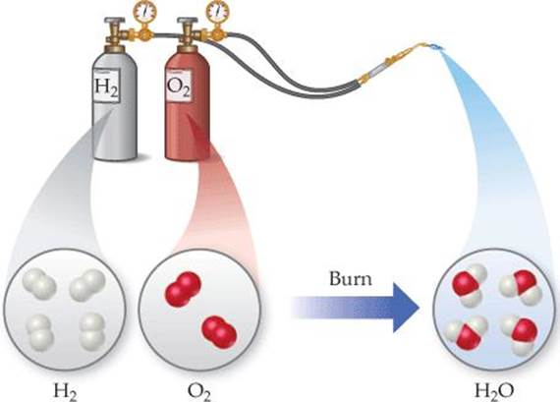**Chemical change**

This is also called a chemical reaction. Chemical change affects the chemical properties of the substance and transforms it into a chemically different substance. When hydrogen burns in air, in figure 2.2 example, it undergoes a chemical change because it combines with oxygen to form water.

*Figure 2.2 Chemical reaction*

***Separation of Mixtures***

Mixtures can be physically separated by using methods that use differences in physical properties to separate the components of the mixture, such as evaporation, distillation, filtration and chromatography.

1. **Filtration**

This is a process used to separate solids from liquids or gases using a filter medium that allows the fluid to pass through but not the solid. In figure 2.3, a mixture of a solid and a liquid is poured through filter paper. The liquid passes through the paper while the solid remains on the paper.

1. **Evaporation**

This is a technique used to separate homogeneous mixtures where there are one or more dissolved salts. The process typically involves heating the mixtures until no more liquid remains. This method drives off the liquid components from the solid components.

1. **Distillation**

This is a method of separating the components of a homogeneous mixture. This process depends on the different abilities of substances to form gases. For example, if we boil a solution of salt and water, the water evaporates, forming a gas, and the salt is left behind.

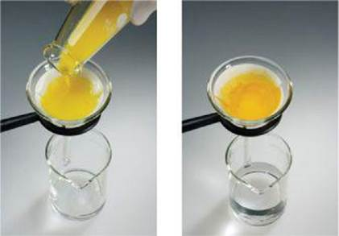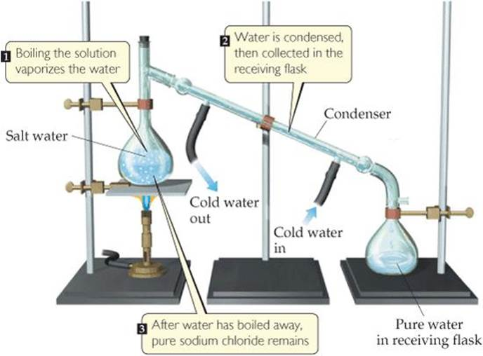

*Figure 2.3 Separation by filtration*

*Figure 2.4 Separation by distillation*

1. **Chromatography**

The basis of this separation process is the differing abilities of substances to adhere to the surfaces of solids. Chromatography literally means “the writing of colors”.

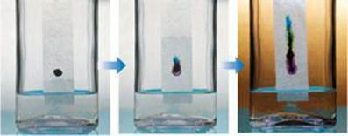

Figure 2.5 Separation of ink into components by paper chromatography

1. **Extraction**

This kind of separation is based on solubility differences. One example is brewing coffee from ground coffee beans.

Example separation of a heterogeneous mixture of iron filings and gold filings.

1. It could be sorted by color into iron and gold. A less tedious approach would be to use a magnet to attract the iron filings, leaving the gold ones behind.
2. We can also take advantage of an important chemical difference between these two metals: Many acids dissolve iron but not gold. Thus we can proceed as follows,

* Put our mixture into an appropriate acid, the acid would dissolve the iron and the solid gold would be left behind.
* The two could then be separated by filtration.
* We would have to use other chemical reactions, which we will learn about later, to transform the dissolved iron back into metal.

1. Activities/Exercises
2. Identify and explain the change that happened in the following example
3. Plants make sugar from carbon dioxide and water.
4. Water vapor in the air forms frost.
5. Label the following as either physical process or chemical process
6. Boiling a pot of water
7. Rusting of a nail
8. Digesting a meal
9. Evaluation/Post-test
10. _____ properties describe the way a substance may change or react to form other substances.
11. What is the method used in separating the components of a homogeneous mixture?
12. Give 3 examples of physical properties of matter
13. Describe the separation methods involved in brewing coffee

**LESSON 3. UNITS OF MEASUREMENT**

1. Learning Outcomes

At the end of the lesson, you can:

1. Discuss the purpose of measuring;
2. Define units of measurement;
3. Perform arithmetic calculations on units of measurement; and
4. Solve application problems involving units of measurement.
5. Time Allotment

1 session (1.5 hours)

1. Discussion

Many properties of matter are quantitative, that is, associated with numbers. When a number represents a measured quantity, the units of that quantity must be specified. The units used for scientific measurements are those of the metric system.

Example:

To say that the length of a pencil is 17.5 is meaningless. Expressing the number with its units, 17.5 centimeters (cm), properly specifies the length.

**The Metric System or International System of Units (SI Units)**

It is the system followed in the units used for scientific measurements. This is an internationally agreed decimal system of measurement.

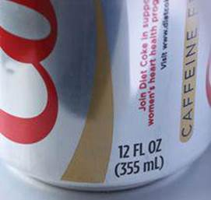The metric system was developed in France during the late eighteenth century. In 1960, an international agreement specified a particular choice of metric units for use in scientific measurements. These preferred units are called International System of Units (SI Units). This is used as the system of measurement in most countries.

**The English System**

The English system, also called the Imperial system of measurements, are both common systems of measurement used today. It uses avoirdupois weight, a traditional system of weight in the British Imperial System and the United States Customary System of weights and measures. This is used in England and many countries including the United States.

*Figure 3.1 Metric units (mL) and English units (ounces, oz)*

TABLE 3.1 Seven (7) Base Units of the SI Units

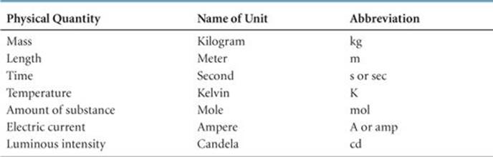

**Mass**

Mass is a measure of the amount of material in an object. Mass measures the quantity of matter regardless of both its location in the universe and the gravitational force applied to it. An object’s mass is constant in all circumstances.

The SI base unit of mass is the kilogram (kg), which is equal to about 2.2 pounds (lb). This base unit is unusual because it uses a prefix, kilo-, instead of the word gram alone.

**Length**

This is the measurement of the extent of something along its greatest dimension. The SI base unit of length is the meter (m), a distance slightly longer than a yard.

**Time**

A unit of time is any particular time interval, used as a standard way of measuring or expressing duration. The SI base unit of time is the second (s).

**Temperature**

Temperature, a measure of the hotness or coldness of an object, is a physical property that determines the direction of heat flow. Heat always flows spontaneously from a substance at a higher temperature to one at a lower temperature. Thus, we feel the influx of heat when we touch a hot object, and we know that the object is at a higher temperature than our hands.

The temperature scales commonly employed in science are the Celsius and Kelvin scales. The Celsius scale was originally based on the assignment of 0 °C to the freezing point of water and 100 °C to its boiling point at sea level (Figure 3.2).

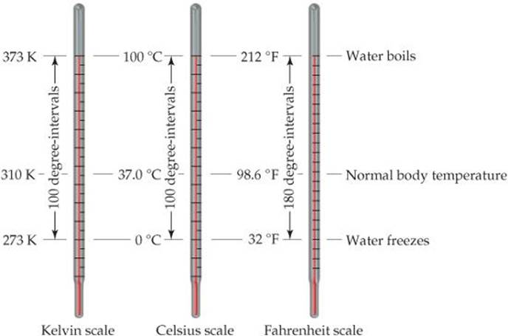

*Figure 3.2 Comparison of the Kelvin, Celsius, and Fahrenheit temperature scales and the temperature conversion formulas*

The Kelvin, Celsius and Fahrenheit scales are related according to the following formula,





The Kelvin scale is the SI temperature scale, and the SI unit of temperature is the kelvin (K). Zero on the Kelvin scale is the lowest attainable temperature, –273.15 °C, referred to as absolute zero. The Celsius and Kelvin scales have equal-sized units—that is, a kelvin is the same size as a degree Celsius. Thus, the Kelvin and Celsius scales are related according to the freezing point of water, 0 °C, is 273.15 K (Figure 3.2). Notice that we do not use a degree sign (°) with temperatures on the Kelvin scale. The common temperature scale in the United States is the Fahrenheit scale, which is not generally used in science.

**Amount of substance**

This is a measure of the number of entities (atoms, molecules, ions, electrons, etc.) present in a substance, expressed in moles.

**Electric current**

An electric current is the rate of flow of electric charge past a point or region. It is measured in Amperes or Coulombs/seconds.

**Luminous intensity**

It is a measure of wavelength-weighted power emitted by a light source in a particular direction per unit solid angle, based on luminosity function, a standardized model of the sensitivity of the human eye. This is the quantity of visible light that is emitted in unit time per unit solid angle. The SI base unit of luminous intensity is the candela.

Table 3.2 Prefixes Used in the Metric System and SI Units

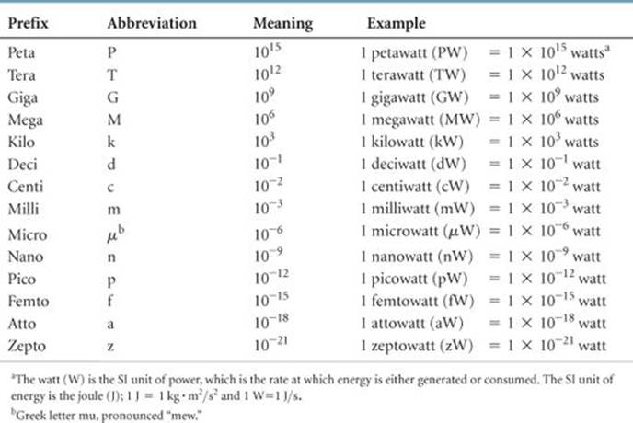

TABLE 3.3 Metric – English Equivalent

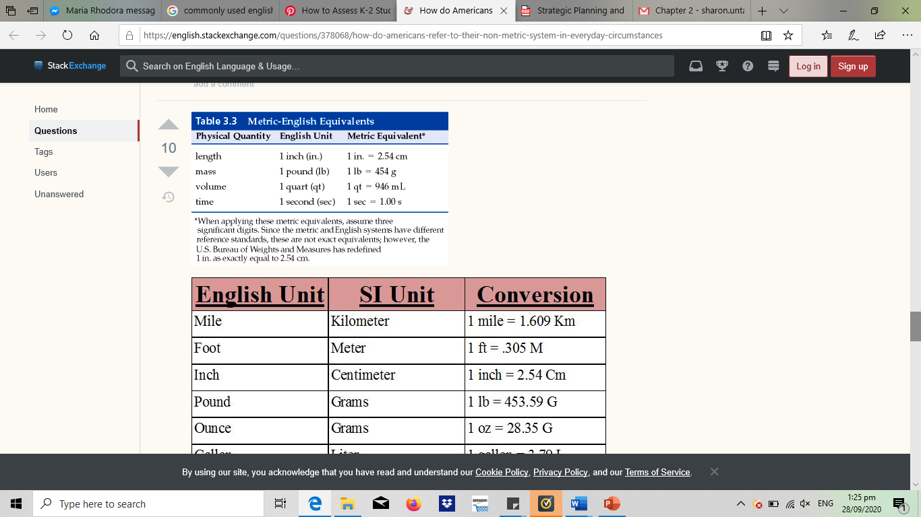With SI units, prefixes are used to indicate decimal fractions or multiples of various units. The table above presents the prefixes commonly encountered in chemistry.

TABLE 3.4 Additional English - Metric Conversion Factors

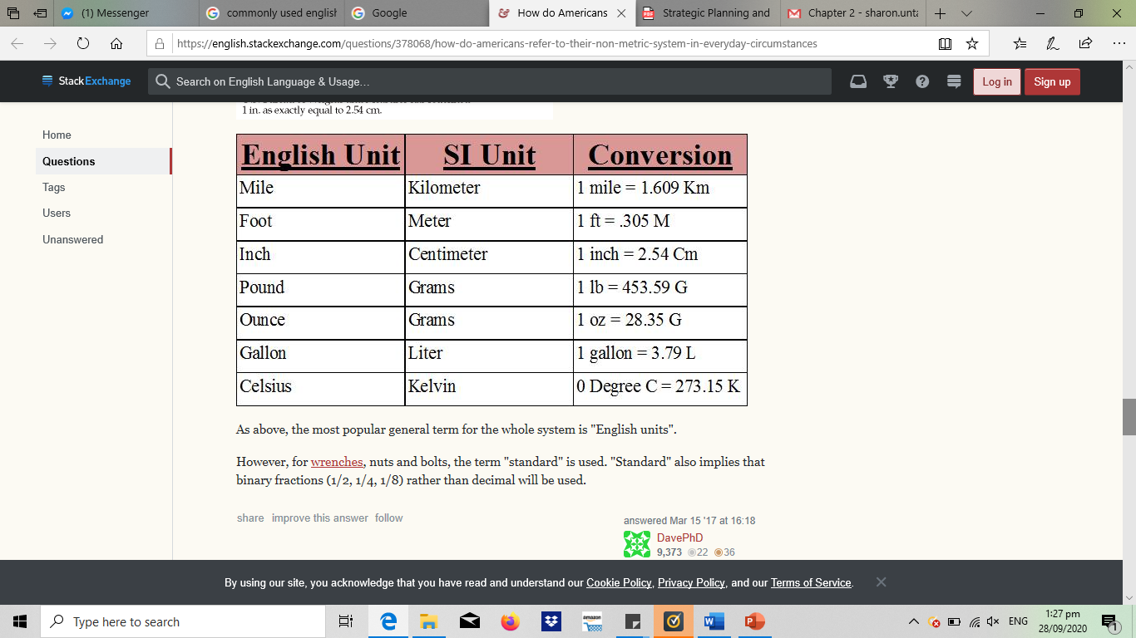

**Derived SI Units**

The SI base units are used to obtain derived units. To do so, we use the defining equation for the quantity, substituting the appropriate base units. For example, speed is defined as the ratio of distance traveled to elapsed time. Thus, the SI unit for speed—m/s, read “meters per second”—is a derived unit, the SI unit for distance (length), m, divided by the SI unit for time, s. Two common derived units in chemistry are those for volume and density.

**Volume**

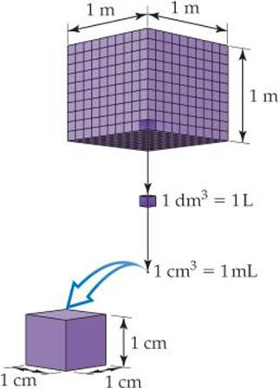The volume of a cube is its length cubed, (length)3. Thus, the derived SI unit of volume is the SI unit of length, m, raised to the third power. The cubic meter, m3, is the volume of a cube that is 1 m on each edge (Figure 3.3). Smaller units, such as cubic centimeters, (sometimes written cc), are frequently used in chemistry. Another volume unit used in chemistry is the liter (L), which equals a cubic decimeter, dm3, and is slightly larger than a quart. (The liter is the first metric unit we have encountered that is not an SI unit.) There are 1000 milliliters (mL) in a liter, and 1 mL is the same volume as 1 cm3:1 mL = 1 cm3.

*Figure 3.3 Volume relationships*

The devices used most frequently in chemistry to measure volume are illustrated in Figure 3.3. The volume occupied by a cube 1 m on each edge is one cubic meter, 1 m3. Each cubic meter contains 1000 dm3. One liter is the same volume as one cubic decimeter, 1L = 1 dm3. Each cubic decimeter contains 1000 cubic centimeters, 1 dm3 = 1000 cm3. One cubic centimeter equals one milliliter, 1 cm3 = 1 mL.

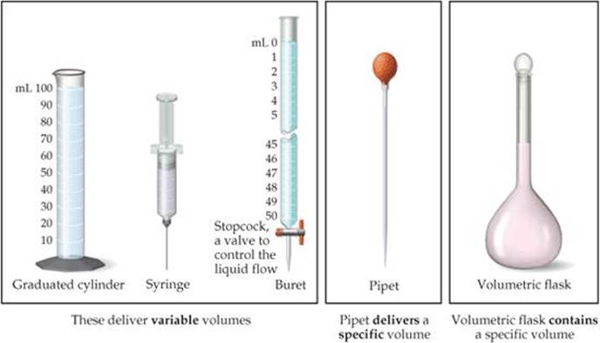

*Figure 3.4 Common volumetric glassware*

**Density**

Density is defined as the amount of mass in a unit volume of a substance:



Table 3.5 Densities of Selected Substances at 25°C

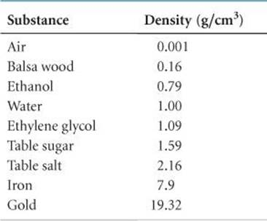

The densities of solids and liquids are commonly expressed in either grams per cubic centimeter (g/cm3) or grams per milliliter (g/mL). The densities of some common substances are listed in Table 3.5. It is no coincidence that the density of water is 1.00 g/mL; the gram was originally defined as the mass of 1 mL of water at a specific temperature. Because most substances change volume when they are heated or cooled, densities are temperature dependent, and so temperature should be specified when reporting densities. If no temperature is reported, we assume 25°C, close to normal room temperature.

The terms density and weight are sometimes confused. A person who says that iron weighs more than air generally means that iron has a higher density than air—1 kg of air has the same mass as 1 kg of iron, but the iron occupies a smaller volume, thereby giving it a higher density. If we combine two liquids that do not mix, the less dense liquid will float on the denser liquid.

1. Activities/Exercises

Using SI Prefixes

(1) Find the name of the unit that equals the following:

(a)10–9 gram

(b)10–6 second

(c)10–3 meter

(2) (a) How many picometers are there in one meter? (b) Express 6.0 × 103 using a prefix to replace the power of ten. (c) Use exponential notation to express 4.22 mg in grams. (d) Use decimal notation to express 4.22 mg in grams.

Converting Units of Temperature

(3) A weather forecaster predicts that the temperature will reach 31 °C. What is this temperature in K?

1. Evaluation/Post-test

(1) Calculate the density of a 374.5-g sample of copper if it has a volume of 41.8 cm3.

(2) A student needs 15.0 g of ethanol for an experiment. If the density of ethanol is 0.789 g/mL, how many milliliters of ethanol are needed?

(3) What is the mass, in grams, of 25.0 mL of mercury (density = 13.6 g/mL)?

(4) Ethylene glycol, the major ingredient in antifreeze, freezes at –11.5 °C.

What is the freezing point in (a) K, (b) °F?

(5) Convert English Units to SI Units. Show your solution.

a. 5 gal to liters

b. 15 lbs to grams

c. 70 ft to meters

d. 50 oz to grams

**LESSON 4. UNCERTAINTY IN MEASUREMENT**

1. Learning Outcomes

At the end of the lesson, you can demonstrate the use of significant figures, scientific notations and SI units in calculations

1. Time Allotment

1 session (1.5 hours)

1. Discussion

Two kinds of numbers are encountered in scientific work:

**Exact numbers**

Exact numbers are those whose values are known exactly. Most of the exact numbers we will encounter in this book have defined values. For example, there are exactly 12 eggs in a dozen, exactly 1000 g in a kilogram, and exactly 2.54 cm in an inch. The number 1 in any conversion factor, such as 1 m = 100cm or 1kg = 2.20461b, is an exact number. Exact numbers can also result from counting objects. For example, we can count the exact number of marbles in a jar or the exact number of people in a classroom.

**Inexact numbers**

Inexact numbers are those whose values have some uncertainty. Numbers obtained by measurement are always inexact. The equipment used to measure quantities always has inherent limitations (equipment errors), and there are differences in how different people make the same measurement (human errors). Suppose ten students with ten balances are to determine the mass of the same dime. The ten measurements will probably vary slightly for various reasons. The balances might be calibrated slightly differently, and there might be differences in how each student reads the mass from the balance.

*Remember: Uncertainties always exist in measured quantities.*

***Precision and Accuracy***

The terms precision and accuracy are often used in discussing the uncertainties of measured values. The dart analogy in Figure 4.1 illustrates the difference between these two concepts.

**Precision** is a measure of how closely individual measurements agree with one another.

**Accuracy** refers to how closely individual measurements agree with the correct, or “true,” value.

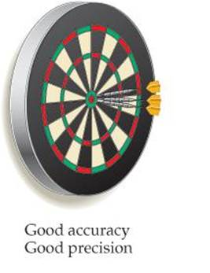 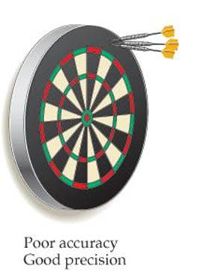 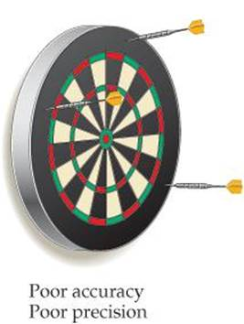

*Figure 4.1 Precision and accuracy*

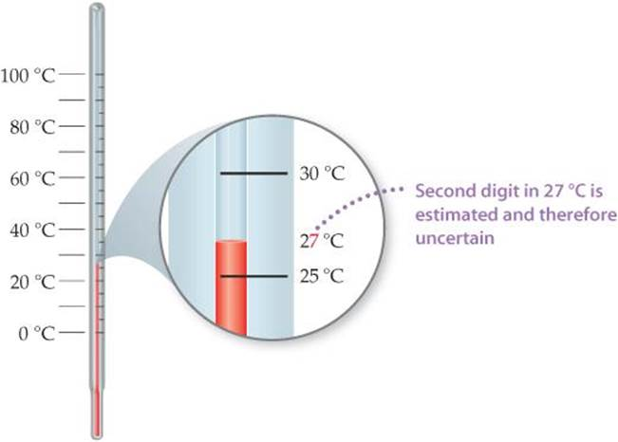In the laboratory, we often perform several “trials” of an experiment and average the results. The precision of the measurements is often expressed in terms of the standard deviation, which reflects how much the individual measurements differ from the average. We gain confidence in our measurements if we obtain nearly the same value each time—that is, the standard deviation is small. Figure 4.1 reminds us, however, that precise measurements can be inaccurate. For example, if a very sensitive balance is poorly calibrated, the masses we measure will be consistently either high or low. They will be inaccurate even if they are precise.

Figure 4.2 shows the thermometer with its liquid column between two scale marks. We can read certain digits from the scale and estimate the uncertain one. Seeing that the liquid is between the 25 °C and 30 °C marks, we estimate the temperature to be 27 °C, being uncertain of the second digit of our measurement.

*Figure 4.2 A thermometer with its liquid column between two scale marks*

**Significant figures** are all digits of a measured quantity, including the uncertain ones. The greater the number of significant figures, the greater the certainty implied for the measurement.

Example. A measured mass reported as 2.2 g has two significant figures, whereas one reported as 2.2405 g has five significant figures

**Determination of Significant Figures**

To determine the number of significant figures in a reported measurement, read the number from left to right, counting the digits starting with the first digit that is not zero. In any measurement that is properly reported, all nonzero digits are significant.

Because zeros can be used either as part of the measured value or merely to locate the decimal point, they may or may not be significant:

1. Zeros *between* nonzero digits are always significant—1005 kg (four significant figures); 7.03 cm (three significant figures).

2. Zeros at the *beginning* of a number are never significant; they merely indicate the position of the decimal point—0.02 g (one significant figure); 0.0026 cm (two significant figures).

3. Zeros at the *end* of a number are significant if the number contains a decimal point—0.0200 g (three significant figures); 3.0 cm (two significant figures).

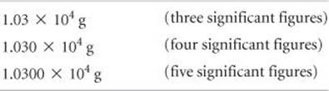A problem arises when a number ends with zeros but contains no decimal point. In such cases, it is normally assumed that the zeros are not significant. Exponential notation (Figure 4.3) can be used to indicate whether end zeros are significant. For example, a mass of 10,300 g can be written to show three, four, or five significant figures depending on how the measurement is obtained.

*Figure 4.3 Example of significant figures*

**Significant Figures in Calculations**

When carrying measured quantities through calculations, the least certain measurement limits the certainty of the calculated quantity and thereby determines the number of significant figures in the final answer. ***The final answer should be reported with only one uncertain digit.*** To keep track of significant figures in calculations, we will make frequent use of two rules, one for addition and subtraction, and another for multiplication and division.

1. **For addition and subtraction, the result has the same number of decimal places as the measurement with the fewest decimal places.** When the result contains more than the correct number of significant figures, it must be rounded off. Consider the following example in which the uncertain digits appear in color:

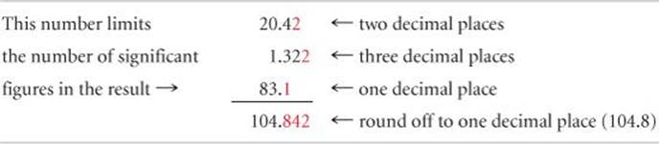

We report the result as 104.8 because 83.1 has only one decimal place.

1. **For multiplication and division, the result contains the same number of significant figures as the measurement with the fewest significant figures.** When the result contains more than the correct number of significant figures, it must be rounded off. For example, the area of a rectangle whose measured edge lengths are 6.221 cm and 5.2 cm should be reported as 32 cm2 even though a calculator shows the product to have more digits because 5.2 has two significant figures.



*Notice that* ***for******addition and subtraction, decimal places are counted*** *in determining how many digits to report in an answer, whereas* ***for multiplication and division, significant figures are counted*** *in determining how many digits to report.*

In determining the final answer for a calculated quantity, exact numbers are assumed to have an infinite number of significant figures. Thus, when we say, “There are 12 inches in 1 foot,” the number 12 is exact, and we need not worry about the number of significant figures in it.

**Rules in Rounding Off Numbers**

In rounding off numbers, look at the leftmost digit to be removed:

* If the leftmost digit removed is less than 5, the preceding number is left unchanged. Thus, rounding 7.248 to two significant figures gives 7.2.
* If the leftmost digit removed is 5 or greater, the preceding number is increased by 1. Rounding 4.735 to three significant figures gives 4.74, and rounding 2.376 to two significant figures gives 2.4.*

1. Activities/Exercises

Relating Significant Figures to the Uncertainty of a Measurement

(1) What difference exists between the measured values 4.0 g and 4.00 g?

(2) How many significant figures are in each of the following numbers (assume that each number is a measured quantity): (a) 4.003, (b) 6.023 × 1023, (c) 5000?

(3) A gas at 25 °C fills a container whose volume is 1.05 × 103 cm3. The container plus gas has a mass of 837.6 g. The container, when emptied of all gas, has a mass of 836.2 g. What is the density of the gas at 25 °C?

(4) To how many significant figures should the mass of the container be measured (with and without the gas) in Exercise 3 for the density to be calculated to three significant figures? Explain why.

1. Evaluation/Post-test

(1) A sample that has a mass of about 25g is placed on a balance that has a precision of ± 0.001g. How many significant figures should be reported for this measurement?

(2) How many significant figures are in each of the following measurements:

(a) 3.549 g, (b) 2.3 × 104cm, (c) 0.00134 m3?

(3) The width, length, and height of a small box are 15.5 cm, 27.3 cm, and 5.4 cm, respectively. Calculate the volume of the box, using the correct number of significant figures in your answer.

(4) It takes 10.5 s for a sprinter to run 100.00 m. Calculate her average speed in meters per second, and express the result to the correct number of significant figures.

**LESSON 5. DIMENSIONAL ANALYSIS**

1. Learning Outcomes

At the end of the lesson, you can

1. Attach the appropriate SI units to defined quantities; and
2. Employ dimensional analysis in calculations
3. Time Allotment

1 session (1.5 hours)

1. Discussion

Throughout the text, we use dimensional analysis in solving problems. In this approach, units are multiplied together, divided into each other, or “canceled.”

**Dimensional analysis**

It is a problem-solving method that uses the fact that any number or expression can be multiplied by one without changing its value. It is also called ***Factor-Label Method* or the *Unit Factor Method***. The key to using dimensional analysis is the correct use of conversion factors to change one unit into another.

It helps ensure that solutions to problems yield the proper units. It also provides a systematic way of solving many numerical problems and checking solutions for possible errors.

**Conversion factor** is a fraction whose numerator and denominator are the same quantity expressed in different units.

Examples

* + 1. 2.54 cm and 1 in. are the same length, 2.54cm = 1 in. This relationship allows us to write two conversion factors:



* + 1. the length in centimeters of an object that is 8.50 in. long is

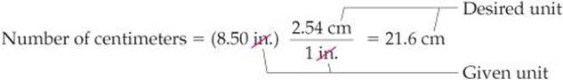

The unit inches in the denominator of the conversion factor cancels the unit inches in the given data (8.50 inches). The unit centimeters in the numerator of the conversion factor becomes the unit of the final answer. Because the numerator and denominator of a conversion factor are equal, multiplying any quantity by a conversion factor is equivalent to multiplying by the number 1 and so does not change the intrinsic value of the quantity. The length 8.50 in. is the same as the length 21.6 cm.

When we multiply a quantity by a conversion factor, the units multiply and divide as follows:

**Using Two or More Conversion Factors**

It is often necessary to use several conversion factors in solving a problem.

Example

1. convert the length of an 8.00-m rod to inches.

The relationship between centimeters and inches (1 in. = 2.54 cm). From our knowledge of SI prefixes, we know that 1 cm = 10–2m.

Thus, we can convert step by step, first from meters to centimeters and then from centimeters to inches:

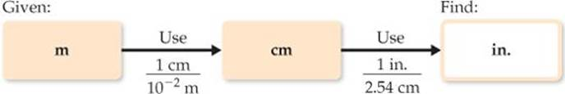

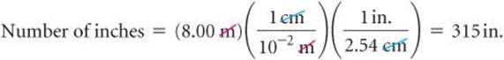Combining the given quantity (8.00 m) and the two conversion factors, we have,

The ***first conversion factor*** is used to cancel meters and convert the length to centimeters. Thus, meters are written in the denominator and centimeters in the numerator.

The ***second conversion factor*** is used to cancel centimeters and convert the length to inches, so it has centimeters in the denominator and inches, the desired unit, in the numerator.

Note that you could have used 100 cm = 1 m as a conversion factor as well in the second parentheses.

As long as you follow your units and cancel them properly to obtain the desired units, you are likely to be successful in your calculations.

**Conversions Involving Volume**

We also have conversion factors that convert from one measure to a different one. The density of a substance, for example, can be treated as a conversion factor between mass and volume.

Example Calculation

Determine the mass in grams of 2 cubic inches (2.00 in3) of gold, which has a density of 19.3g/cm3. The density gives us the conversion factor of,

Because we want a mass in grams, we use the first factor, which has mass in grams in the numerator. To use this factor, however, we must first convert cubic inches to cubic centimeters.

The relationship between inches and centimeters is given: 1 in = 2.54cm (exactly). Cubing both sides of this equation gives (1 in.)3 = (2.54cm)3, from which we write the desired conversion factor:



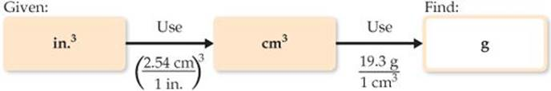The procedure is diagrammed here. The final answer is reported to three significant figures, the same number of significant figures as in 2.00 in3 and 19.3 g.

1. Activities/Exercises
2. If a woman has a mass of 115 lb, what is her mass in grams? (Use the relationships between units)
3. Determine the length in kilometers of a 500.0-mi automobile race.
4. The average speed of a nitrogen molecule in air at 25 °C is 515 m/s. Convert this speed to miles per hour (mi/hr).
5. Evaluation/Post-test
6. If the volume of an object is reported as 5.0 ft3, what is the volume in cubic meters?
7. A car travels 28 mi per gallon of gasoline. How many kilometers per liter will it go?
8. Earth's oceans contain approximately 1.36 × 109 km3 of water. Calculate the volume in liters.

Reference

Brown, Theodore L. et.al. (2015). Chemistry: The Central Science

**Rubric for essays and discussions:**

|  |  |  |  |
| --- | --- | --- | --- |
| **Features/Score** | **1 (0%)** | **3 (50%)** | **5 (100%)** |
| Content/Ideas, 50% | No answer | Identified the topic and provided additional information | Presented important and accurate information |
| Quality of writing,  30% | No answer | The information presented was somewhat organized and clear | The idea presented was organized and highly informative |
| Grammar and usage, 20% | No answer | Multiple spelling and grammatical errors | Virtually no spelling or grammatical errors |

**Chapter 1 Additional Exercises (to follow in separate worksheet)**



**Congratulations for completing this module!**

**Student’s Information**

Name:

Program:

Year and Section:

Contact No.:

E-mail address:

Facebook Account:

Messenger Account:



**Vision 2020**

WPU: the leading knowledge center for sustainable

development of West Philippines and beyond.

**Core Values (3CT)**

Culture of Excellence

Commitment

Creativity

Teamwork

**Mission**

WPU commits to develop quality human resource and green technologies for a dynamic economy and sustainable

development through relevant instruction,

research and extension services.